

*National University of Computer & Emerging Sciences Islamabad*

# D igital Logic Design

**L ab # 03**

## Student Name: Muhammad Ahmed Baig Reg#

***Lab Section:20i-1884***

### L ab Title:

Logic Gates (NOR, XOR, XNOR)

### O bjectives:

* To become familiar with the operation of Basic Gates (NOR, XOR, XNOR) using ICs.
* To become familiar how to determine the truth tables for logic gates

### E quipment Required:

* DEV-2765ETrainer Board
* 7402 quad 2-input NOR gate IC
* 7486 quad 2-input XOR gate IC
* 4077 quad 2-input XNOR gate IC

### B ackground Theory

Logic deals with only two normal conditions: logic TURE or logic FALSE. In Boolean logic, TRUE is often represented by the term HIGH or the number 1 and FALSE is represented by the term LOW or the number 0. HIGH and LOW (1 or 0) are logic terms; they do not indicate whether the voltage is higher or lower. In positive logic the more positive voltage is TRUE and the less positive voltage is FALSE i.e +2.5V = HIGH and +0.5V = LOW. With the negative logic this definition is reversed.

The basic logic gates and their symbols are summarized in the following pages. The truth table with all possible input combination is given and the output is left empty to you as an exercise. All possible combination of inputs involve counting in binary from 0 to 2n – 1 where n is the number of inputs.

In this experiment you will look at the truth tables for several arrangements of simple gates

### G ATES, THEIR IC PIN CONFIGURATION & TRUTH TABLES:

***-Input NOR Gate***

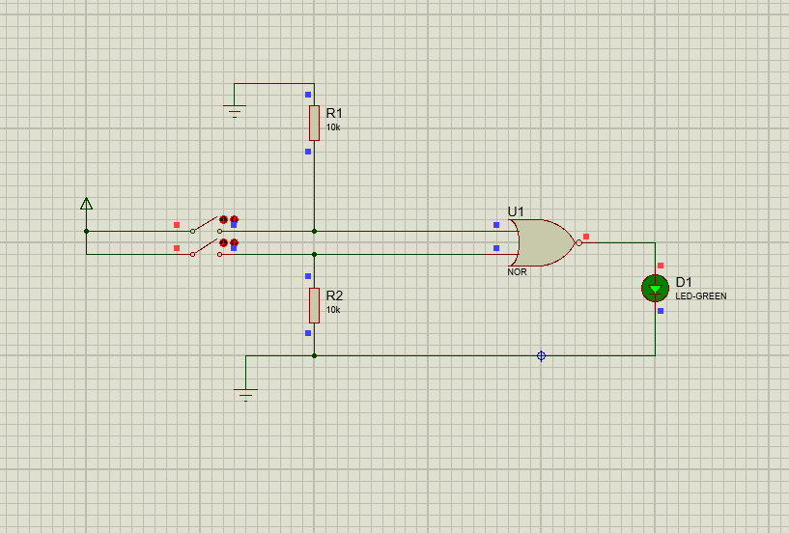

***Truth Table***

|  |  |  |
| --- | --- | --- |
| Input | | Output |
| X | Y | Z |
| 0 | 0 | 1 |
| 0 | 1 | 0 |
| 1 | 0 | 0 |
| 1 | 1 | 0 |

***-Input X-OR Gate***

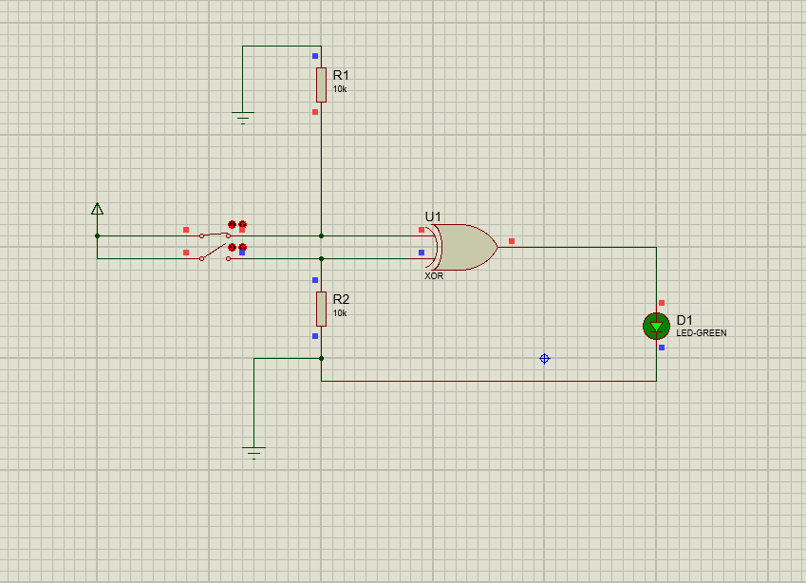

***Truth Table***

|  |  |  |
| --- | --- | --- |
| Input | | Output |
| X | Y | Z |
| 0 | 0 | 0 |
| 0 | 1 | 1 |
| 1 | 0 | 1 |
| 1 | 1 | 0 |

***X-NOR Gate***

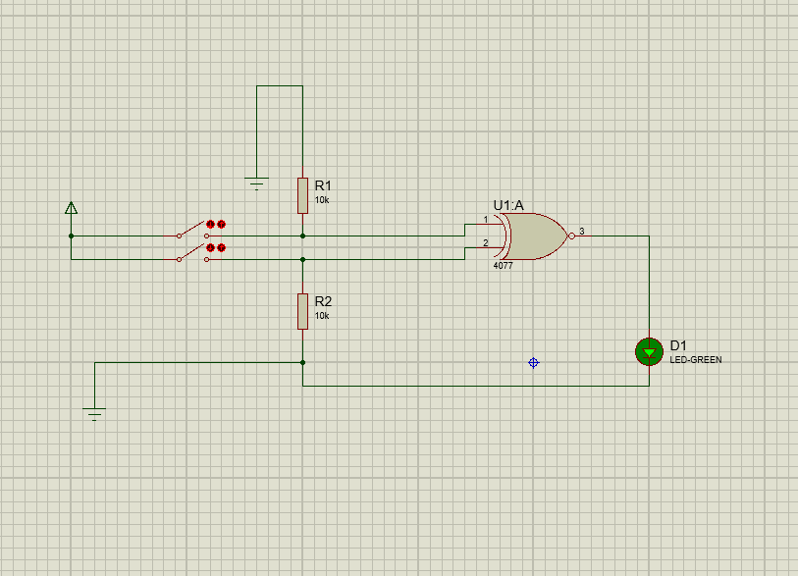

***Truth Table***

|  |  |  |
| --- | --- | --- |
| Input | | Output |
| X | Y | Z |
| 0 | 0 | 1 |
| 0 | 1 | 0 |
| 1 | 0 | 0 |
| 1 | 1 | 1 |

***P rocedure***

* 1. Connect the trainer board with the power supply
  2. Mount the corresponding 74LSXX IC on the board.
  3. Connect pin 14 to +5 V and pin 7 to GND.
  4. Wire the circuit according to the diagram by consulting the corresponding gate ICs data sheet.
  5. Apply all the combinations of inputs and observe the output on the LED to verify the truth tables of the gates.

***TASK 4***

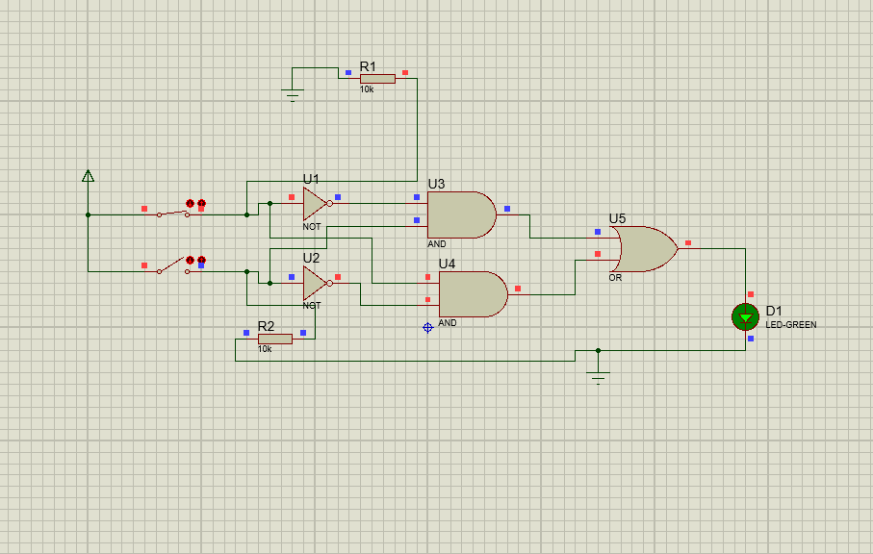

***Truth Table***

|  |  |  |  |  |  |  |
| --- | --- | --- | --- | --- | --- | --- |
| Input | | Working | Working | Working | Working | Output |
| X | Y | X` | Y` | (Y.X`) | (X.Y`) | Z |
| 0 | 0 | 1 | 1 | 0 | 0 | 0 |
| 0 | 1 | 1 | 0 | 1 | 0 | 1 |
| 1 | 0 | 0 | 1 | 0 | 1 | 1 |
| 1 | 1 | 0 | 0 | 0 | 0 | 0 |

***TASK 5***

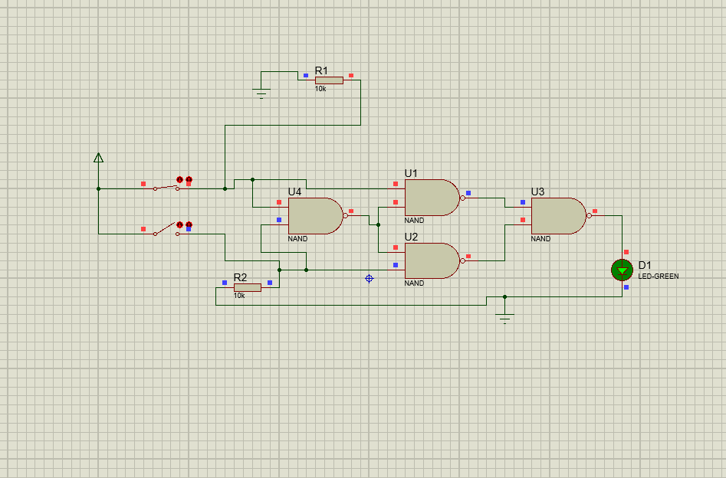

***Truth Table***

|  |  |  |  |  |  |  |
| --- | --- | --- | --- | --- | --- | --- |
| Input | | Working | Working | A | B | Output |
| X | Y | (X.Y)` | ((X.Y)`.X)` | ((X.Y)`.Y)` |  | (A+B) |
| 0 | 0 | 1 | 1 | 1 | 0 | 0 |
| 0 | 1 | 1 | 1 | 0 | 1 | 1 |
| 1 | 0 | 1 | 0 | 1 | 1 | 1 |
| 1 | 1 | 0 | 1 | 1 | 0 | 0 |